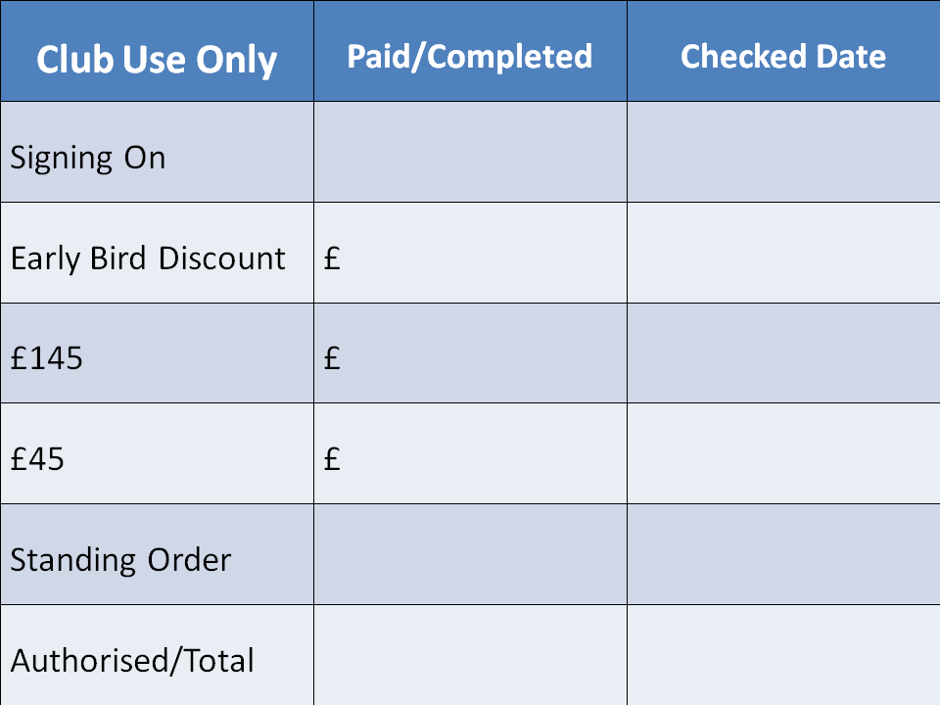

**Signing-on Form**

**2020-21 Season**

##### *Please complete the Player, Parent/Guardian & Emergency contact details below*

|  |  |  |  |  |  |
| --- | --- | --- | --- | --- | --- |
| **Full Name of Player** |  | | **Date** | |  |
| **Player FA Registration number if known** |  | | Date of Birth | |  |
| **Address** |  | | | | |
|  |  | | | | |
| **Postcode** |  | Home Phone Number | |  | |
| **nName of Existing/Previous Football Club** |  | | | | |
| **Player’s Mobile over 16s only** |  | Player’s Email over 16s only | |  | |
| **Mother’s Name & DOB** |  | Father’s Name & DOB | |  | |
| **Mother’s Mobile** |  | Father’s Mobile | |  | |
| **Mother’s Email** |  | Father’s Email | |  | |
| **Mother’s Occupation** |  | Father’s Occupation | |  | |
| **Emergency Contact Name** |  | Emergency Phone Number | |  | |

Your personal data will only be used for football purposes in line with our privacy notice, which can be found on our website and this sets out how BLGFC uses and protects any personal data that is collected by us.

The full price of signing on for the 2020/21 season is £145 plus a minimum of one hour a month of voluntary time given to the Club.

The fee must be paid when signing on either as a single payment of £145 OR a payment of £45 plus £10.00 per month from July to April (inc) via a standing order, to be set up by the bill payer, although this may vary for players who sign on during the season.

**COVID-19 – Depending on when the season starts the cost for the season may be subject to change and this will be reflected on your invoice, once issued.**

A new Standing Order set up is required each season.

There are two training sessions per week and girls are expected to attend both if possible.

# There are no fee reductions. Cheques must be made payable to “Bedford Ladies & Girls FC”

Please complete this form, and either

* Pay £45 by cheque, cash or transfer and set up the standing order of £10.00 per month from 01 July 2020 to 01 April 2021 inc
* Or pay the full annual fees of £145 by cheque, cash or transfer

ALL MONEY TRANSFERS MUST USE THE PLAYER’S/PLAYERS’ NAME(S) AS THE TRANFER REFERENCE

***Whichever way payment is made it is to cover the whole season and therefore if a player leaves after 3 months then the whole amount is still to be paid.***

**All players wishing to leave the Club during the season MUST inform The Club Secretary in writing and cc the Club Treasurer or it will be considered that the player is still part of the Club.**

When leaving the Club Players must ensure that all payments have been made in full and that all kit and equipment belonging to the Club has been returned. Failure to do this will mean that clearance to play elsewhere will not be granted and/or the Player will be suspended from playing Football.

|  |
| --- |
| Any medical information/allergies etc. |

Please sign below to accept - I have read the club code of conduct (available on the Club website) and agree to abide by it and that I/we have read, understood and signed the consent form as attached.



*By completing the box below we and you are accepting this as your signature*

|  |  |  |
| --- | --- | --- |
| Player | Parent/Guardian Name | Parent/Guardian Signature |