PRESS RELEASE – 10.05.2014
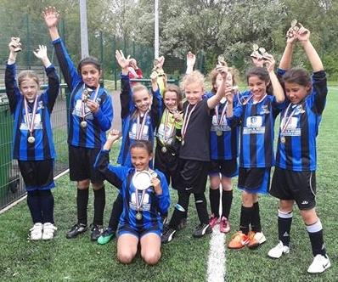

From Left to Right: Abbie O’Keefe, Zainish Butt, Chelsey Kelk, Courtnee Kinsella, Ophelia Humphrey, Holly Garraway, Mya Banghar, Chloe Esposit and in front Freya Hazelwood

Bedford Ladies & Girls FC U10s Carry On The Club’s Winning Streak

Saturday morning saw the curtain fall on the Bedford Girls Under 10s season with the BHWFL 5 a side competition at AFC Kempston.

The under 10s were competing in the Shield competition and opened their account with a victory over Dunstable. Almost straight from the starting whistle Ophelia Humphrey latched on to a loose ball before rounding a defender and running on to slot the ball past the keeper with her left foot. This instilled a confidence in the side which went on to win the first game convincingly which included a great hat-trick from Mya Banghar.

The girls carried their good start into the next game against Westoning who were beaten in a game that the Bedford defence were rarely troubled and in which Courtnee Kinsella scored her first and well deserved goal for the Club.

The final game saw the girls matched up against Leighton United in what was a tight game that ended up with Bedford securing their third win of the day. This ensured the trophy was on its way to Bedford Girls U10s.

This was a great team effort from a group of girls who have only been together for a few months but seem to be growing stronger every week.

The team are coached by Vickie Kelk and Andy Humphrey. They train twice weekly and anyone interested in joining the Club please come along to our trials to be held Monday 19 and 26 May and Thursday 23 and 30 May at Westfield Middle School grounds, Chester Road from 6-7pm for 7-13 year olds and 6:30-dusk for 14s and up. If you would like to attend or want any more information on the Club please see our website Bedfordladies-girls.org or text to Annette on 07970 650 573.

Bedford Ladies & Girls FC would like to thank the Organisers, Beds & Herts Women's and Girls' Football League, for a great day.

